Practical Revision

Practical 2

1. Sudo -i : login as root user
2. Pwd : show the current path
3. Mkdir <filename> : to create directory
4. Ls -a : list all contents at current directory including hidden filds
5. Cd <directory> : go in/out of directory
6. Touch <filename> : create empty file
7. 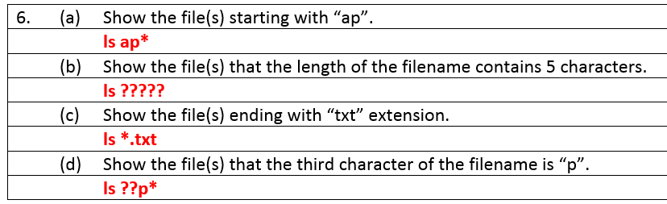
8. Find -name <filename> : search for a directory/ filename
9. Rm <filename> : remove file
10. Rm -r <directory> : remove directory
11. Vi <filename> : edit file / create file if not exist
    1. Press esc button to go into command mode
    2. “a” button to append text in it
    3. wq : write and quit
    4. q!: quit without saving / force quit
12. wc <filename> : show the word count of file
13. cat <filename> : show content of the file
14. cat > <filename> : this is to create a file and input content
15. cat <file1> <file2> > <file3> : combine file1 and file2 to file 3
16. tar -c -f <archivefilename> <file1> <file2> : archive file1 and file2 into archivefilename.tar (similar to zip in windows)
17. cp <file1> <directory> : copy the file1 to selected directory
18. mv <file> <directory> : move the file to selected directory
19. :s/the/THE/g : search for word “the” and change to “THE” throughout the current line
20. :1,$ s/the/THE/g : Search for “the” and change to “THE” from line 1 until end of the line
21. ln old new – create a hardlink
22. ln -s old new – create a softlink

Practical 3

1. id : display information bout a user’s UID and which group assigned to
2. group : Display information on the groups in which you are a member
3. sudo adduser <newuser> : add a user called newuser
4. su <newuser> : switch to newuser
5. exit : logout from user
6. ls -l : to list all directory and file with authority (permission) info
7. chmod 777 <filename>
   1. 1st 7 is for user
   2. 2nd 7 is for group
   3. 3rd 7 is for others
   4. 4- read, 2- write, 1-execute
   5. Get the authority you want, add them up and put into the command
8. chmod ugo+rwx <filename>
   1. This is similar to 777, u stand for user, g stand for group, o stand for others, if you want to set for all, use a
   2. R-read, w-write, x- execute
   3. U can either add authority by using +, remove by using – or reassign the authority using =
9. umask 272 : this is to set the default authority for file newly created, the 272 is terbalik compare with chmod, in this case means all new created file will have authority 505.

By default, the file will have access mode with 666 and directory with 777

1. cp -s <doc1> <softlink> : create a symbolic link of **doc1** file to **softlink** in your home directory
2. less <file> : display content of file page-by-page
3. passwd <username> : to change user password

Practical 5

1. ctrl+z : to stop foreground process
2. bg: to start the stopped process in background
3. fg: to start the stopped process in foreground
4. fg *<jobID>* : start a process with particular job id in foregrounds
5. <cmd> &: execute process in background
6. jobs: list contents of job control
7. ps: list all running process
8. pstree : list all running process in tree structure

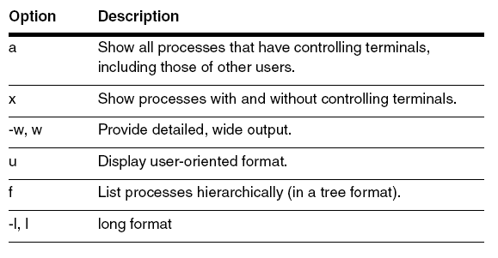

1. nice –n -3 xeyes : start the xeyes process with nice value -3
2. renice 5 <pid> : set nice value for the process to 5
3. top : view process information in a continuously updated list, press “q” to stop
   1. top -d 5 : change default delay to 5sec
   2. top -n 3 : make top command to quit after 3 refresh
4. kill <pid> : terminate the process
5. killall : kill all processes with an indicated command name, eg: killall xeyes will terminate all xeyes process
6. sleep 5 : sleep for 5 sec, u may change the 5 to 2m to sleep for 2min or 3h to sleep for 3 hours
7. nohup find -size +100k > log.txt & - this is to start the process and make it continues even after you logout of system, highlighted part is the command to execute, & is to run in background.
8. Crontab -e : edit or create crontab file. After this command is entered, system will prompt for input for the cron job. (may refer p5Ex q7)
   1. * - any possible value
   2. , - multiple value, eg: 1,2,4
   3. - -range of value, eg: 1-5
9. Crontab -l : list crontab file.
10. Crontab -r : remove crontab file.

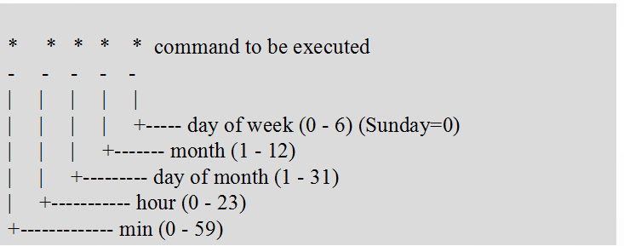

1. At – schedule command when it should be execute (may refer p5q6)

Practical 6 – go through your practical and slide I uploaded to classroom, most of the command are included.